Assignment 2
Date Assigned: 2/29/2015
Due: Midnight 3/14/2015 on iLearn

Please read turn-in checklist at the end of this document before you start doing exercises.
Section 1: Pen-and-paper Exercises

- Using iteration, find a tight bound for the solution of the following recurrence equation. Assume that you know that 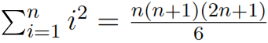, and 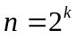(n is a power of 2).
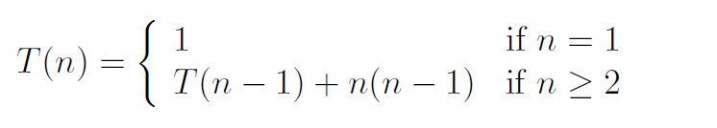
Note: Credit will not be given only for answers - show all your work:
(5 points) steps you took to get your answer.
(5 points) your answer.

- Analyze the following code and provide a "Big-O" estimate of its running time in terms of n. Explain your analysis.

int k = n;
while (k > 0) {
for (int j=0; j < n*n; j++)
sum += data[j];
k = k / 2;
}

Note: Credit will not be given only for answers - show all your work:
(5 points) steps you took to get your answer.
(5 points) your answer.

- Consider the following problem (30 points):
Given k sorted lists, design an algorithm to merge them into one sorted list. Assume n is the total number of elements in all the input lists. Analyze your algorithm’s running time.
Important: In all of the assignments of this course, when you are asked to give an
algorithm for a problem, you are (unless otherwise indicated) expected to
(i) describe the idea behind your algorithm in English (10 points);
(ii) provide pseudocode (10 points);
(iii) analyze its running time (10 points).
Regarding requirement (iii): Unless otherwise specified, show the steps of your analysis
and present your result using big-O.

- Trace Merge Sort on the following array (10 points):
1, 7, 6, 8, 0, 2, 5
Note: Write down steps showing the state of the array after each recursive level of the Merge Sort algorithm, and mark the order of steps.

Section 2: Java Implementation
- Assume k = 3, implement problem 3 in Java (30 points).
Note:
Find a file called Problem3.java in assignment 2 folder.
Complete the method of mergeklists().
Test your method in the main method provided following the comments.

- Write a recursive method that computes f(n) using the following formula (30 points):
f(n) = 1 if n = 0
f(n) = 1 + 1 / f(n-1) if n > 0
Note:
Find a file called Problem6.java in assignment 2 folder.
Complete the method of f().
Test your method in the main method provided following the comments.

TURN-IN CHECKLIST:

- Answers to Section 1 (.doc/.txt), and to Section 2 (all your source Code (.java files)). Remember to include your name, the date, and the course number in comments near the beginning of your code/report.

- Create a folder and name it 'FirstName_LastName_assignment_2'. In the newly created folder copy and paste your files (.doc/.txt/.java files). Then compress the folder, and push it to GitHub.

